BLOODWYCH
The A.H.Q Adventures

The Streets of Delmortis 3
Act One: Shadows Stir in the Ruins 3
Act Two: The Wight’s Return 5
Act Three: The Graveyard of Delmortis - The Lord of the Forgotten 6
Mid-Battle Twist: 7
Astroth’s Struggle: 7
Final Confrontation and Resolution: 7
Epilogue 7
The Zendite Legacy 8
Act 1 – The Forgotten Paths Beneath MoonHenge 8
The Journey Begins 8
The Collapsed Trail 8
Corridors of the Forgotten 8
Quest Room/Area: Lair of the Serpent Guardian 9
Final Battle & Resolution 9
Act 2 – Echoes of the Forgotten 10
Corridor & Room Exploration 10
Quest Room/Area: The Chamber of the Watchers 11
Final Battle & Resolution 12
Act 3 – The Stones of the Zendites 13
Corridor & Room Exploration 13
Quest Room/Area: The Standing Stones of MoonHenge 14
The Final Confrontation 15
Final Battle & Resolution 16
Epilogue 16
The Greenwood of Groghurst 17
Act I – The Wildwood’s Awakening 17
Scene Setting: 17
Corridor & Room Exploration 17
Quest Room/Area: 18
Act II – The Cursed Ruins 19
Corridor & Room Exploration 19
Quest Room & Boss Encounter: 20
Act III – The Heart of the Wildwood 20
Corridor & Room Exploration 20

The Streets of Delmortis

Act One: Shadows Stir in the Ruins
The streets of Delmortis lay eerily silent, a city once teeming with life now reduced to a graveyard of empty buildings and forgotten alleyways. The champions of the Bloodwych, their purpose clear, moved cautiously through the desolate avenues, keenly aware that they were not alone.  At first, the signs of undeath were sparse—shambling zombies and brittle-boned skeletons that fell swiftly beneath blade and spell. The heroes found their confidence growing; the undead, it seemed, were not the dire threat they had feared. But that confidence was short-lived. | 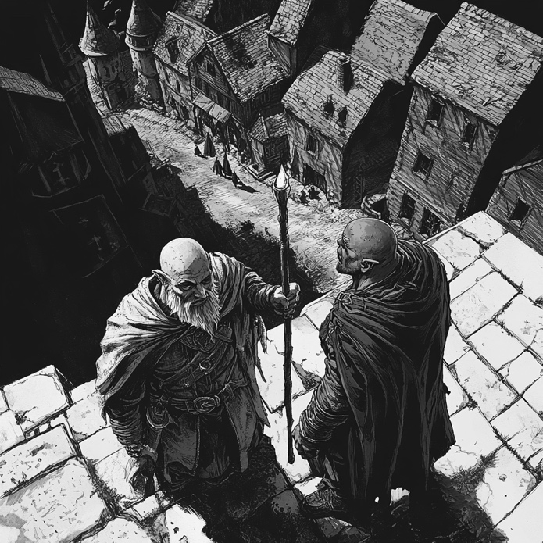
A deeper mystery lingered in the abandoned structures. Behind crumbling walls and collapsed corridors, the layout of Delmortis seemed… wrong. A secret chamber, hidden behind a false wall, yielded nothing but a cryptic rune-etched table, a lingering trace of something foul at work. Elsewhere, mold-choked rooms and decayed bureaucratic offices revealed only empty desks, as though the city had been abandoned in an instant.

Still, there were dangers beyond the restless dead. A gas trap, set in an otherwise unremarkable hall, nearly ensnared them—an ominous sign that something watched over their progress, preparing for their arrival.

The streets gave way to something more sinister. A lair, at first unimpressive, where zombies and skeletons fell with ease. But beyond, in the shadows of a ruined chamber, lurked a presence far more menacing: a Wight.

The battle was swift and brutal. Though the Wight’s presence filled the air with unnatural dread, the heroes’ resolve held strong. Baldrick struck first, his cunning allowing him to bypass the mind-numbing fear that such creatures instilled. Zothen, sensing the depths of its corruption, unleashed Flames of Death, but the Wight’s form proved resistant to magic. The undead horror pressed forward, drawing forth more wandering minions to swarm the party from behind. Elfric’s arrows flew true, thinning their ranks, while Astroth carved a path through rotting flesh with raw Orcish might.

The Wight moved with eerie intelligence, seeking out the weakest link. Baldrick, despite his bravado, felt the bite of its Strength Drain and was forced to retreat before more of his lifeforce was siphoned away. The battle raged, and when Astroth’s axe finally struck the decisive blow, the Wight let out a ghastly wail and vanished into the ether, its presence lingering like a whisper in the walls.
The fight had drained them, yet more perils lay in wait. A treasure chest, seemingly the reward for their efforts, concealed a mantrap, snapping shut with a vicious hunger. Only Astroth’s resilience spared him from a maiming wound.

Their search led them at last to another chamber—the first true clue to Delmortis’ dark fate. A final undead horde lay in wait, led by a grim Undead Champion, its rusted blade still gleaming with the memories of old wars. And again, from the shadows, the Wight returned.

This time, the battle was grueling. The warriors threw themselves into the fray, cutting down the lesser undead. Zothen, determined to break the stalemate, launched another deadly burst of Flames of Death, this time searing the Wight and obliterating its lesser minions. But the horror persisted. Baldrick, seeking to end the fight, delivered what should have been the final stroke—only for the Wight to turn fate against him. It endured, draining strength from those around it, forcing the champions to spend their own will to resist its corruption.

Elfric, bloodied but unrelenting, seized the moment. A precise sword strike shattered the Undead Champion’s defenses, and as the Wight recoiled, he let fly a single, well-aimed arrow—one that struck true, piercing the creature’s spectral form and banishing it once more into the void. But even in its defeat, it did not truly die. It slipped into the cracks of the walls, retreating into the very bones of Delmortis.

The champions, now weary, stood before a choice. They had fought well, but the Wight remained, its very existence a stain upon the city. More horrors surely lay below, where the heart of the corruption festered.

Would they return and regroup, steeling themselves for another assault? Or press forward, into the depths of Delmortis, where greater terrors and darker truths awaited?

Act Two: The Wight’s Return
The heroes, weary but resolute, descended the narrow staircase, the scent of decay thickening with each step. The air grew colder, not with the chill of stone, but with something unnatural, as though the walls themselves recoiled from what lay beneath Delmortis.  They emerged into a new quarter of the city — a place where once merchants hawked wares, now abandoned to ruin. Shattered market stalls lay in heaps, and faded signs of old shops swayed silently in a breeze that should not have been. | 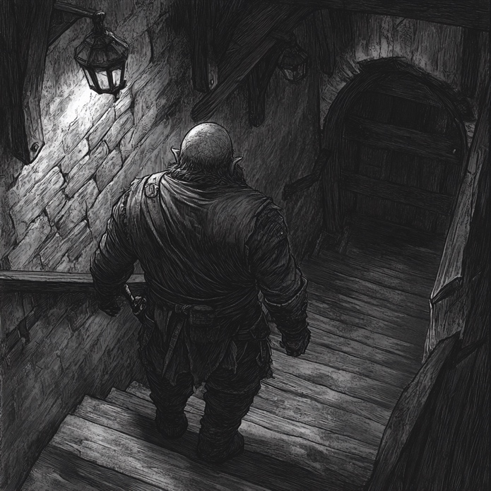
Baldrick, ever observant, paused near a collapsed well. “The ground here… it’s sunken, as though something’s tunnelled beneath. Recently.”

Astroth growled, gripping his axe tightly. “Not something… somethings. There’s more here than restless corpses.”

As they advanced, they encountered ghouls, fast and ravenous, leaping from doorways with blackened claws. Yet, despite their ferocity, something was amiss — these creatures did not seem to fight to kill. They fought to delay.

Elfric, sensitive to the unnatural, was the first to notice. “They’re… buying time.” His voice was strained, the Elven senses prickling with the awareness of a looming presence.

Through a crumbling gate, the party entered an overgrown courtyard, ringed by decaying statues of Delmortis’ founders. And there, waiting, was the Wight they thought vanquished… yet it seemed stronger now, more whole. Its eyes burned with a cold, intelligent malice.

Zothen, sensing the arcane shift, whispered grimly, “It was sent back… not defeated. Something called it back.”

The battle was fierce. The Wight’s strikes carried a withering force, draining vitality with each blow. But as Astroth’s axe shattered its spectral armour, the creature laughed — a dry, rattling sound.

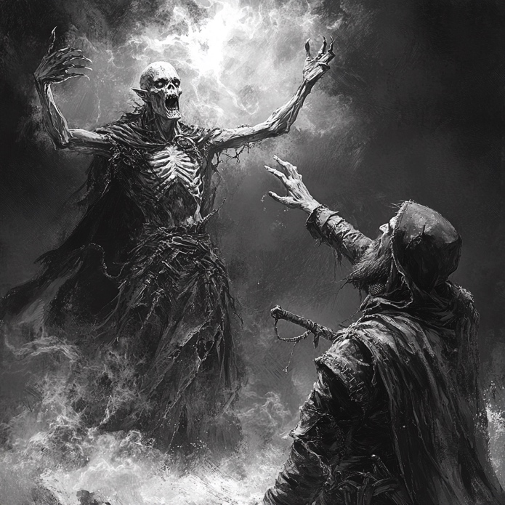 | “You… cannot… stop what is bound,” it hissed, retreating into the shadows once more. But this time, it left behind a clue: a sigil of Chaos, scorched into the cobblestones where the Wight had stood.  Baldrick knelt beside it, brushing away ash. “This… this isn’t just dark magic. This is Zendick’s taint.”  A chill passed over the group. The presence of a Chaos sigil meant only one thing — the undead invasion of Delmortis was not a natural occurrence of restless souls, but a ritual.
And the Wight was no rogue spirit; it was a sentinel, guarding something greater.
From a nearby ruin, a staircase led deeper into the earth, black mist rising from its depths. “The source of this… lies below,” Zothen whispered.

As they descended, the echoes of the Wight’s laughter followed them.

Act Three: The Graveyard of Delmortis - The Lord of the Forgotten
The stairs led them into an ancient necropolis, a city of tombs hidden beneath Delmortis. Dust and bones lay thick on the ground, and the oppressive air made even Astroth’s hardy Orcish blood feel sluggish.

Gravestones jutted from the cracked earth, many bearing sigils of old noble houses long thought extinct. But among them were fresh graves… dozens, perhaps hundreds, and each one hummed faintly with necromantic energy.

At the heart of the graveyard stood a ruined mausoleum, its doors cracked open as if torn apart from within. Elfric felt it first — the presence of something ancient, hateful, and wrong.

“They’ve been raising the dead for weeks,” he whispered. “This… this is a summoning ground.”

As they approached, the earth trembled. The Wight returned once more, but now, it did not fight alone. From the graves rose skeletal knights, still clad in the rusted remnants of their battle gear, eyes burning with unnatural light.

Yet the true horror emerged from the mausoleum: The Lord of the Forgotten, a colossal undead warlord, wrapped in decaying burial shrouds, its skull crowned with a tarnished iron circlet. A voice, ancient and hollow, echoed across the graveyard:
“You trespass upon the domain of Delmortis, where the dead obey their true master. Zendick’s Chaos flows through these stones… and through me.”

This was no ordinary necromancer — this was a servant of Chaos, once a noble protector of Delmortis, now twisted by Zendick’s lingering influence into a vessel of undeath.

Mid-Battle Twist:
• As the heroes fight, the sigil of Chaos seen earlier begins to pulse, growing stronger.
• Zothen, attuned to Dragon Magic, senses that the Chaos is not simply feeding the undead — it’s preparing a rift.
• The only way to stop the rift is to destroy the Lord of the Forgotten… but the rift’s energy is affecting Astroth, awakening something primal and violent within him.

Astroth’s Struggle:
• The Orc warrior, already touched by Chaos magic, begins to hear whispers — a seductive voice offering power, reminding him of the rage and betrayal of his past.
• He must fight not just the undead, but the temptation to unleash Chaos himself, knowing that doing so could break the summoning but also consume him.

Final Confrontation and Resolution:
• The heroes must destroy the Lord of the Forgotten, break the sigil, and close the Chaos rift before Delmortis is lost forever.
• In the climactic moment, Astroth’s willpower and Zothen’s arcane might combine — Zothen channels Dragon Magic to contain the rift, while Astroth delivers the final blow to the undead warlord, rejecting the Chaos within him.
• As the Lord of the Forgotten falls, it reveals its purpose: Delmortis was to be Zendick’s stronghold upon his return, a city of the dead, feeding the Chaos that would herald his resurrection.
• The city is saved, but the heroes know the threat has not been ended — merely delayed. The taint of Zendick still lingers beneath the surface of Trazere… and Delmortis will never be the same.

Epilogue
As dawn breaks over the ruined city, the streets are quiet once more — but now, not with death, but with a fragile peace.

Astroth, though victorious, carries the weight of what he resisted.

Elfric’s compassion, Baldrick’s resilience, and Zothen’s wisdom proved enough to turn the tide… this time. But as they leave Delmortis, the sigil of Chaos, though broken, left its mark on all of them.

The Zendite Legacy

Act 1 – The Forgotten Paths Beneath MoonHenge

The Journey Begins
The path to MoonHenge was long and steep, winding through the rugged northeastern highlands of Trazere. The mountains loomed to the north and west, jagged peaks cutting through a storm-heavy sky. To the south, far below, stretched the valley leading to Creyndor, the last bastion of civilization before the land gave way to forgotten relics of the past.

The heroes—Astroth, Megrim, Eleanor, and Elfric—had set out at dawn, following rumors of strange lights in the night sky, eerie voices whispering on the wind, and villagers vanishing near the ruins. As they climbed higher, the very air seemed heavier, charged with something ancient, thick with an oppressive energy.

“It feels… familiar,” Megrim murmured, rubbing her hands together as if tracing unseen patterns in the air. The MoonWych had sensed it since they left Creyndor—a lingering magic, something that resonated with her own.

Astroth, marching ahead, glanced back. “You recognize this power?”

She hesitated. “No. But it recognizes me.”

That was the last conversation they had before reaching the first sign of trouble.

The Collapsed Trail
The main path had crumbled away—an old mountain road once leading straight to MoonHenge now reduced to a sheer drop. But something else had disturbed this trail. The rocks were scratched and scored, as if something had burrowed through the earth beneath.
Elfric knelt, running his fingers along the grooves in the dirt. “This wasn’t just erosion… something broke through here. Recently.”

Eleanor peered down the slope, spotting an unnatural darkness beneath an overhang of stone. “There’s a cave. That might be our way forward.”

There was no other option but to descend carefully, navigating loose rock until they reached the cavern’s entrance. The air was warmer here, humid, carrying the scent of damp stone and decay.

Corridors of the Forgotten
They stepped inside, torches flickering as the tunnel swallowed them. The passage twisted unnaturally, some walls rough and natural, others suspiciously smooth, as if carved long ago.
The deeper they went, the more evidence they found that this was no mere cave.
- Symbols of the Zendites, barely visible beneath layers of dust, adorned sections of the walls.
- Faint runes pulsed with residual magic, though too eroded to decipher.
- Fragments of stone altars and shattered pillars lay abandoned in the dark, remnants of a place long forgotten.
Megrim traced a hand over the stone, feeling its pulse beneath her fingertips. “This place wasn’t just built… it was infused with magic. And whatever was buried here…” she hesitated, her voice barely above a whisper, “...it isn’t sleeping anymore.”

Astroth tightened his grip on his axe. “Then we’ll make sure it stays buried.”

The path forked, corridors winding deeper into the ruins. As they advanced, a distant, rhythmic sound began to echo through the halls—like hissing breath, accompanied by the scrape of claws against stone.

Something knew they were here.

Quest Room/Area: Lair of the Serpent Guardian
At last, the corridors opened into a vast, hollowed-out chamber. At its center stood a massive Zendite obelisk, cracked and weathered but still radiating power.

They barely had time to take it in before movement stirred around them.

Emerging from the shadows, scaled horrors slithered into view—Lizardfolk, their reptilian eyes gleaming with malice, weapons slick with venom. They hissed in unison, as if welcoming the intruders to their doom. But something else stirred, something larger.

A deep, reverberating hiss filled the chamber, and from the darkness behind the obelisk, it emerged—the Serpent Guardian.

It was no ordinary beast. Its coiled body stretched across half the chamber, scales the color of wet stone, shifting as if barely tethered to reality. But most unnerving were its eyes—pale, white, and filled with knowing intelligence.

As the Lizardfolk rushed forward, the Guardian spoke, its voice slithering into their minds.
“You… do not belong here. The Zendites’ secrets… are not for you.”

Then, with a sound like a landslide, the battle began.

Final Battle & Resolution
- The Serpent Guardian strikes from the shadows, using the obelisk as cover while its Lizardfolk followers swarm the heroes.
- The chamber trembles, dust and stone falling as the battle rages.
- When the Guardian finally falls, its body dissolves into mist, its last words lingering in the heroes’ minds:
“The Zendites… await…”

As silence settles over the chamber, Elfric approaches the obelisk. “There’s something here.”
Carved at its base, half-hidden beneath moss and age, a stairway spirals downward into darkness.

Astroth, bloodied but steady, wipes his blade clean. “We’re not done yet.”
With that, the heroes step forward, descending into the depths beneath MoonHenge…

Act 2 – Echoes of the Forgotten
The stairway twisted downward, its stone steps worn smooth by time. The air grew cold and dry, carrying the scent of dust and something older—magic long dormant, but never fully gone.

As the heroes descended, Megrim ran her fingers along the wall, where ancient Zendite carvings flickered in the torchlight. Symbols of the moon, the stars, and… something else.

“There’s power still lingering here,” she murmured.

Astroth grunted, adjusting his grip on his axe. “Then we’re walking into something’s territory.”

Elfric, ever cautious, scanned the shadows ahead. “Whatever it is… it’s been waiting.”

At the bottom of the stairway, the corridor opened into a vast underground ruin, a labyrinth of high-vaulted passageways and crumbling archways. The walls bore faintly glowing inscriptions, but the language was unfamiliar—even to Megrim. The corridors stretched endlessly ahead, twisting into darkness.

Then came the whispering.

A soft, overlapping murmur, like voices speaking just out of reach. It was not the sound of the dead, nor the echoes of a living tongue—it was something half-remembered, as though the very walls of this place were trying to recall a time long past.

Corridor & Room Exploration
The party advanced cautiously, torches casting long shadows. The ruins seemed to shift and distort the deeper they went, as if space itself were not entirely stable.
They passed through chambers filled with Zendite relics, untouched by time:
- A room containing a shattered stone lectern, as if something had once been read aloud here, then violently silenced.
- A sunken courtyard, where Elfric noted faint, unnatural footprints that did not belong to any living being.
- An altar-like pedestal, bearing two empty slots, their shape unmistakable—they once held gems.
Megrim ran a hand over the indentations. “The Bluish Gem… the Tan Gem… they were part of this place.”

Eleanor frowned. “If they were taken… where are they now?”

Megrim’s fingers twitched against the stone. A pulse of familiar power resonated from the altar, and for a brief moment, she saw visions—tall, hooded figures, their hands raised toward the heavens, chanting beneath a glowing sky.

Then the vision was gone.

Megrim staggered, gripping the edge of the pedestal. “The Zendites weren’t just builders.
They… they were channelers. They didn’t carve these stones just to shape the land. They used them to move across it.”

Astroth looked around at the endless halls. “Then maybe that’s why they were overthrown. If you control movement itself, you control everything.”

A thought lingered unspoken in all their minds: If the Zendites had mastered teleportation, what else had they hidden beyond reach?

Quest Room/Area: The Chamber of the Watchers
As they moved deeper, the whispering grew louder, no longer just murmurs but something aware of their presence. The corridors opened into a vast, circular chamber, its domed ceiling carved with unfamiliar constellations.

Floating in eerie silence were three massive, many-eyed forms—the Watchers, their massive spherical bodies drifting weightlessly, each eye twitching in separate directions. They did not move to attack. They simply watched.

Then, the largest among them spoke—not with words, but directly into their minds.

“You come seeking what was lost.”

The air itself seemed to press inward, thick with unspoken judgment.

“You are not the first. Others have sought the Zendites’ knowledge. Others have been purged.”

Astroth stepped forward, his grip tightening on his weapon. “We’re not here to steal your secrets.”

The Watcher’s largest eye turned toward him.

“All who enter seek to claim what is forbidden.”

The whispering intensified, the inscriptions on the walls flickering as if waking from dormancy. The Watchers drifted closer, their gaze stripping away illusion, revealing things unseen.

For a moment, each hero saw something… personal.
- Astroth saw himself, alone, standing atop a pile of bones—Orc and Human alike. The last of his kind, abandoned by all.
- Eleanor saw Delmortis, swallowed by shadow, its streets lined with silent, motionless figures who did not breathe.
- Elfric saw the Eternal Forest… burning. Its great oaks turned to ash, the rivers running black.
- Megrim saw the moon… shattered.
Then, all at once, the vision snapped away.

The Watcher’s voice darkened.
“You are not meant to be here.”

The whispering became a roar, and the battle began.

Final Battle & Resolution
The Watchers attacked not with weapons, but with power over reality itself.
- Their gaze fractured space, shifting corridors mid-step, sending the heroes stumbling into false paths and reflections of rooms that did not exist.
- Their magic drained memory, attempting to erase the intruders’ very reason for coming.
Through sheer will and combat prowess, the heroes fought through the illusions, striking true. When the final blow landed, the Watchers let out a sound that was not a scream, but a sigh—as if releasing something long held back.

As the last of them faded into mist, the whispers stopped. The chamber fell completely silent.

At the far end of the room, a new path revealed itself—a stairway, ascending back toward the surface.

Elfric exhaled, shaking off the lingering effects of the Watchers’ visions. “Whatever’s ahead… we’re not done with them yet.”

Megrim lingered a moment, looking at the fading inscriptions on the walls. She placed a hand against the stone.

“The Zendites were feared for what they knew. And now we’ve proven we can reach them.”

She turned to the others, her expression unreadable. “I just don’t know if that’s a good thing.”

With nothing left below, they climbed. MoonHenge awaited.

Act 3 – The Stones of the Zendites
The stairway twisted upward, the walls tighter than before, forcing the heroes into a single-file march. The silence was absolute—no echo of their footfalls, no shifting of dust, as though the very stones refused to acknowledge their presence.

Megrim, near the front, pressed a hand to the wall. “The magic here is different.”

Astroth frowned. “Different how?”

She hesitated. “It’s awake.”

The moment they stepped into the next chamber, the torches guttered and died. A pale blue glow pulsed along the walls, outlining the edges of massive, engraved slabs. The air was thick with stagnant energy, the kind that should have faded long ago—but never did.

Ahead, the corridor split into three paths. The choice, it seemed, was theirs to make.

Corridor & Room Exploration
The ruins shifted subtly the further they went, the architecture no longer entirely Zendite. Druidic carvings appeared alongside the older symbols, as if history had layered itself upon the stone.

Each corridor led to a different piece of the puzzle.

Path of Reflection – The Mirror Chamber
The first path ended in a room lined with cracked obsidian mirrors. The air was cold, unnaturally so, and the reflections flickered just out of sync with reality.
Elfric moved cautiously, watching his own reflection hesitate, a half-second behind his true movements.

“I don’t like this.”

As they stepped further inside, the reflections changed—not just mirroring them, but showing different versions of themselves:
- Astroth in rusted, blackened armor, his eyes cold and empty.
- Eleanor kneeling before a figure of shadow, a sword driven into her own chest.
- Elfric’s bow shattered at his feet, the Eternal Forest burning behind him.
- Megrim, standing atop MoonHenge, her robes Zendite blue, arms raised in invocation.
Megrim gasped, stepping back. The moment she did, the mirrors shattered, and the illusions vanished.

Eleanor steadied her. “You okay?”

Megrim clenched her jaw. “Let’s move.”

Path of Stone – The Forgotten Archive
A great stone hall stretched before them, lined with Zendite pillars, each engraved with runic inscriptions. Some had been defaced, the words scratched out or burned away.

Astroth ran a gauntleted hand along the markings. “What were they trying to erase?”

At the far end of the room, they found a half-buried pedestal. Carved upon it was an inscription in the old tongue.

Megrim knelt, tracing the letters. Her voice was distant as she read aloud:

“The Druids did not steal the stones. They only stole time. The Zendites remain. The Zendites… wait.”

A chill passed through the group.

The Zendites had never left.

Path of the Moon – The Lunar Gate
At the end of the third path, a half-collapsed gateway stood beneath an engraving of the full moon. The runes pulsed faintly, and the air tingled with residual power.

Megrim reached forward, almost instinctively, before stopping herself.

“This… this is where the Bluish and Tan Gems belonged.”

Eleanor frowned. “You mean… they were part of a portal?”

Megrim exhaled. “Maybe. Or maybe something more. If these stones once allowed the Zendites to move freely… then what if they weren’t just trying to escape?”

Elfric looked toward the corridor ahead. “What if they were trying to return?”

A deep tremor rumbled through the ruins. The message was clear.

It was time.

Quest Room/Area: The Standing Stones of MoonHenge
The ruins ended abruptly. The walls gave way to open air, and the heroes stepped out onto the plateau of MoonHenge itself.

The standing stones loomed, bathed in the pale light of the full moon. The grass was dead, the soil ashen, as if the land itself had been untouched by time.

At the center of the henge stood three robed figures, their skull-like faces illuminated only by the glow of the stones. Beneath their tattered robes, tentacle-like appendages twitched as they turned, moving with slow, deliberate purpose.

The Zendites had returned.

The Final Confrontation
One of them stepped forward, his voice layered with echoes of the past.  “You come seeking what was lost.”  Megrim exhaled sharply, stepping forward before the others could stop her.  “You were the first. The true masters of the stones.”  The Zendite inclined his head. “We were.”  Astroth’s grip tightened on his axe. “Then what are you now?” | 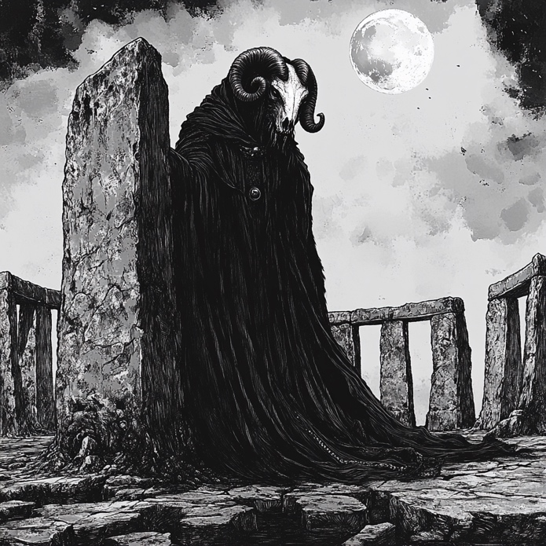
A pause. Then, the Zendite’s jaw cracked open, splitting in an unnatural way.

“We are what was left behind.”

The other two Zendites raised their scythes, and the standing stones shuddered, pulsing with unnatural energy.

“The Druids cast us into the void.”

“The world forgot us.”

“But the stones… remembered.”

The air thickened, a pulse of raw lunar energy crackling through the circle. The Zendites raised their arms, and the stones answered.

“We have returned. And we will not be forgotten again.”

Then, all at once, they attacked.

Final Battle & Resolution
- The Zendites fight with warped space and time, using the standing stones to shift positions unpredictably.
- The land itself rebels, creating illusions of past battles, forcing the heroes to fight through shadows of history.
- The stones must be disrupted to weaken the Zendites, or they will continue to regenerate.
As the battle reaches its climax, Megrim, battered but defiant, pushes forward toward the central stone.

The Zendites turn to her. “You understand us. You are one of us.”

For a fleeting moment, the magic recognizes her. The power is hers to claim. A choice lingers in the air.
- She can accept it, unlocking ancient Zendite knowledge… at the risk of becoming something else.
- She can reject it, breaking the Zendites’ hold and severing the past from the present.
The choice is hers.

Epilogue
The battle ends, one way or another.

The Zendites’ forms collapse, unraveling into dust, their whispers fading into the wind.
The standing stones fall silent, their glow dimming once more.

The moon hangs overhead, watching, waiting.

Elfric looks across the plateau. “It’s over.”

Astroth shakes his head. “No. Just… paused.”

Eleanor turns to Megrim. “You knew, didn’t you? That you had some connection to this place.”

Megrim doesn’t answer immediately. Instead, she looks up at the moon, her expression unreadable.

“I think… they wanted me to remember.”

The Zendites were gone. But their story was not over.

And the stones would always remember.

The Greenwood of Groghurst

Act I – The Wildwood’s Awakening
Deep in the woodlands bordering Groghurst, twilight falls over a forest once known for its serene beauty. Now, gnarled trees lean in as if whispering warnings. The soft rustle of leaves is punctuated by distant, feral cries—a prelude to the gathering chaos. Rumors have reached the champions: savage Beastmen, driven mad by some primeval force, are stirring in the wildwood.

Corridor & Room Exploration
As the heroes convene at the forest’s edge, Sir Edward adjusts his shining helm and speaks with resolute authority.
Sir Edward: “Keep your wits about you, friends. These woods are no longer the peaceful refuge they once were. The reports speak of Beastmen, but something tells me there’s more to their fury than mere hunger.”
Sethra, the Earth Ranger with a haunted past, surveys the uneven terrain, his eyes narrowing as he spots claw marks in the soft soil.
Sethra: “I know these scars well—they are the language of nature, speaking of disturbances deep beneath the roots. I suspect our foes are not born overnight but are awakened by a forgotten curse.”
Murlock, ever the scholar of forbidden lore and redemption, studies a crumbling stone with faded runes.
Murlock: “These symbols hint at ancient wards—protective magics once meant to keep balance. Now, they lie shattered. It appears the very force that guarded these woods has been defiled.”
Roseanne, agile and sharp-eyed, darts ahead along a narrow path, her voice light yet tinged with concern.
Roseanne: “Over here, look! Tracks that are far too large for any ordinary goblin. These prints belong to beastly forms—creatures that have forsaken reason in favor of raw savagery.”
Together, the party threads through dense underbrush, following a trail of broken branches and deep, ominous footprints. The forest seems alive with a palpable tension—a foreboding sense that nature’s balance teeters on the edge.

Quest Room/Area:
Their journey brings them to a clearing encircled by massive, ancient oaks. At its center, a crude, ramshackle fortification has been erected from scavenged wood and stone. Savage roars echo from within. Entering the clearing, the heroes are confronted by the Beastman Chieftain—a towering figure with mottled fur, sharpened tusks, and eyes alight with feral cunning.
Sir Edward (drawing his sword): “Stand firm! We fight not just for ourselves but for every soul threatened by this madness.”
The battle is fierce. Sethra’s arrows find their mark among the chieftain’s thick hide; Murlock channels earth-bound spells to destabilize the beast’s fury; Roseanne nimbly flanks the enemy, her daggers a blur; and Sir Edward leads the charge with unwavering honor. After a hard-won clash, the chieftain falls with a final bellow.
As its roar dies, a hidden stone staircase emerges at the edge of the clearing—a passage carved into the earth itself. The heroes exchange determined looks before descending, the first step in unraveling the mystery behind this savage uprising.

Act II – The Cursed Ruins
The stone steps lead to a forgotten ruin nestled among towering ferns and tangled vines—a relic of an ancient civilization lost to time. Here, crumbling arches and moss-covered pillars hint at a once-sacred site. Now, the ruins serve as a gathering place for the Beastmen, whose ferocity has taken on an eerie, organized semblance. The air is thick with the scent of damp earth and ancient magic.

Corridor & Room Exploration
In the dim light of the ruin, Murlock carefully inspects an inscribed slab.
Murlock: “These carvings… They speak of a covenant between man and nature, a pact that has now been shattered. The curse that defiles this place must have seeped from the very heart of these stones.”
Sir Edward strides purposefully among the broken columns, his noble tone tempered with concern.
Sir Edward: “A kingdom built on honor has fallen to ruin, its guardians turned savages. We must restore what has been lost—not merely to vanquish the Beastmen, but to rekindle the old light of order.”
Sethra, feeling the pulse of the earth beneath his feet, stops to run his fingers along an ancient totem.
Sethra: “I can sense the corruption. It is as if the land itself is screaming in agony, its lifeblood tainted by this vile curse.”
Roseanne, ever resourceful, scouts ahead.
Roseanne: “There’s movement in the shadows. These ruins hide more than just crumbling stone—there’s a lair here, and the heart of this blight must be there.”
Their conversation deepens their resolve as they piece together the tragic history of the site: once a sanctuary of renewal, it now pulses with the dark energies that have driven the Beastmen to madness.

Quest Room/Area:
At the center of the ruins lies a once-sacred courtyard, now defiled. Amid toppled statues and shattered altars, the heroes face the Beastman Druid, a twisted figure wielding primal earth magic—a corrupted guardian who once protected these lands.
Sir Edward: “Stand ready! This abomination has perverted the sacred rites of old.”
A heated battle ensues. Murlock’s spells shatter the unnatural energies; Sethra uses his deep bond with the earth to ground the feral magic; Roseanne’s swift strikes expose the beast’s vulnerabilities; and Sir Edward’s valor inspires the group as he leads the counterattack. With a final, decisive blow, the Beastman Druid falls, its malevolent influence dissipating like smoke.
In the center of the courtyard, as the dust settles, a concealed archway reveals itself—a stone passageway descending further into the dark heart of the cursed lands. The heroes, emboldened by their victory, descend the staircase, leaving the ruined sanctuary behind.

Act III – The Heart of the Wildwood
The staircase opens into a vast, subterranean glade—a hidden sanctum where the wildwood and ancient magic merge in an otherworldly embrace. Bioluminescent flora casts a soft, emerald glow on rugged stone, and a quiet power hums in the air. The glade, though breathtaking, is tinged with sorrow—a final echo of a sacred past now corrupted by a lingering curse.

Corridor & Room Exploration
Here, in the stillness of the underground glade, the heroes reflect on their journey. Murlock deciphers cryptic runes etched into the glade’s perimeter.
Murlock: “These markings tell of a time when nature and civilization were one. The curse that haunts these woods was meant to protect, not to enslave. We have seen the Beastmen’s madness, but there is a force twisting that balance—a dark spirit that clings to these ruins.”
Sir Edward surveys the glade, his voice filled with quiet determination.
Sir Edward: “Our quest is not just to vanquish the enemy before us, but to heal the land. The honor of Trazere depends on restoring the natural order.”
Sethra, drawn by the pulsing energy beneath his feet, speaks with a measured tone.
Sethra: “I feel the ancient heartbeat of this earth. It is wounded, scarred by a force it cannot comprehend. We must confront the source of this corruption.”
Roseanne, ever perceptive, adds with a note of urgency.
Roseanne: “The answers lie at the center of this glade. That’s where we’ll find the origin of the curse—and the final test.”

Their journey leads them to a vast circular clearing dominated by a towering stone pedestal entwined with living vines and etched with ancient symbols. At the pedestal stands the Beastman Overlord—a colossal, fearsome figure whose roar reverberates through the sanctum, embodying the curse that has twisted nature’s guardians into savage warriors.

Quest Room/Area:
In the radiant clearing, the Beastman Overlord emerges as the living embodiment of the corrupted wildwood. Its massive form is part beast, part manifestation of the ancient curse, and its eyes burn with a feral, unyielding light.
Sir Edward (raising his sword): “For the honor of Trazere—and for the soul of these woods—we end your reign of terror now!”
The ensuing battle is monumental. Murlock unleashes torrents of primal magic; Sethra channels the raw power of the earth, his every strike a plea for nature’s redemption; Roseanne darts through the melee, her blades a blur of precision; and Sir Edward’s unwavering leadership bolsters their collective strength. Amid roars and clashing steel, the Overlord’s fury is finally subdued by their combined might.
As the beast falls, the curse’s grip loosens. The stone pedestal cracks open, revealing a hidden, spiraling staircase bathed in gentle, natural light—the path to renewal. With the Beastman Overlord defeated, the corruption that had twisted the wildwood begins to ebb away.

Epilogue:
Ascending the staircase, the heroes emerge back into the familiar woodlands near Groghurst. The air seems lighter, and the forest regains a hint of its ancient, unblemished beauty. Though scars of the dark days remain, hope is kindled anew—an enduring testament to the valor and unity of Sir Edward, Murlock, Sethra, and Roseanne. Their journey has not only saved the wildwood but restored a piece of Trazere’s lost legacy, a promise that even the deepest curses can be undone by steadfast hearts.
Feel free to adapt or expand upon this adventure as needed to further enrich your lore and integrate additional narrative nuances!

